Things you need to know for Semester 1 2020 live streaming

For Semester 1, 2020, you have chosen to engage with your subject via Echo360 live streaming. Here’s some important information to ensure you get the best possible experience.

Before you start
You will be able to view the lecture, post questions through Echo360, and listen to the audio live and remotely on your device. An internet connection is required to access the service. For a successful streaming experience, please check you are using:

- Either a desktop or laptop computer running either Windows 10 or MacOS 10.12.1 (or higher)
- One of the following browsers: Edge, Safari, Chrome or Firefox.

On the day of the live streamed lecture
- Login to Canvas, click on your unit then click on the Echo360 ALP button:

- From the Class list, click on the Class that has the green LIVE icon displayed:
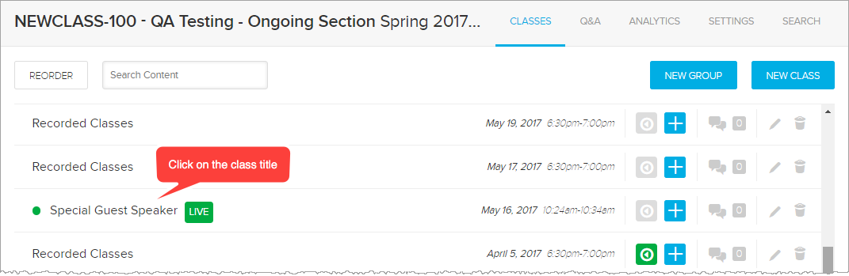
- Click Show Live Stream to see the live stream. Your lecturer will use the Discussion forum built into Echo360 ALP to keep tabs on questions you may ask. Click on the Discussion icon to open the panel:
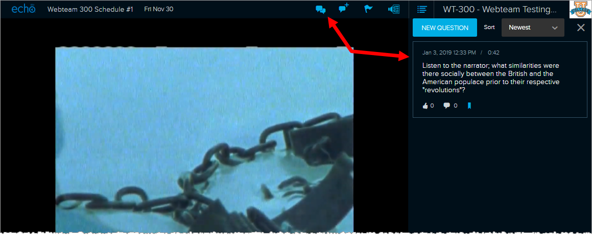

Common issues:
- Please make sure you have setup your computer as per the instructions above in the “Before you start” section.
- If there are issues relating to the live stream, your lecturer will post information in the Canvas Announcements section for that unit and update as and when there are updates.
- Whilst you may wish to try other configurations to view the live stream, please understand that the university will only support the platforms and software mentioned above in the “Before you start” section.
- It is important to remember that your recorded lecture will be available in Canvas later in the day. So there is no need to panic if your connection drops out. Just log in later when you lecturer has uploaded the recorded stream.
- If you have configured your computer correctly and you are still having issues during a live stream, please contact the IT Service Desk on 9214 5000 and tell the support officer that you are using the live streaming service.

